OCAP Subversion Orientation

1. About This Document 1
2. Project Conventions And Policies 1
3. Resources 2
4. New Subversion Repositories 2
5. Essential Subversion Concepts 3
6. Basic Usage - Check Out, Edit, Status, Update and Check In 4
7. Other Usage 11
8. Advanced Topics 14
9. TortoiseSVN 18
10. Subclipse Plug-In for Eclipse 24
11. Status Codes For “svn update” Command 25
12. Status Codes For “svn status” Command 25
13. Subversion Command Cheat Sheet 26
14. TortoiseSVN Lessons Learned 31

About This Document
This document is intended to provide an initial foundation of knowledge on Subversion and how it is used in the Open Cable group. The emphasis is on test developers and how they can check out, edit and check back in files. This document is not intended to be exhaustive training. For an exhaustive explanation of Subversion, see the Subversion manual at http://svnbook.red-bean.com/.

Conventions used in this document:
Text within curly braces is a required part of a command.

Text within square brackets is optional.

Italicized text is copied verbatim from the Subversion manual. Other un-annotated plagiarisms occur throughout the document.

Project Conventions And Policies
Only store in Subversion the files that are used to produce deliverables, not the deliverables themselves. For example, code and Makefiles go into Subversion, but (with a few exceptions) not executables, zip files or tar files. These types of files should be stored on a shared drive that is regularly backed up.

File types to NOT be included are
Executables
Log files
Tar files
Zip files
Tarred and Zipped Files

Resources
This is the online Subversion manual. It is the O’Reilly book offered in HTML format, and is the main source of information used in this document.

For details about anything discussed in this document, see the Subversion manual.
http://svnbook.red-bean.com/

This is the main site of the Subversion project on tigris.org and offers downloads, project roadmaps, and FAQs about Subversion.
http://subversion.tigris.org/

Subclipse is a Subversion plug-in for the Eclipse IDE.
http://subclipse.tigris.org/

Tortoise SVN is a graphical tool for accessing Subversion repositories from Windows. This is the recommended client for Windows based development.
http://tortoisesvn.tigris.org/

“The Top Ten Subversion Tips for CVS Users” is an article by one of the authors of the Subversion manual. It provides a quick overview of differences between CVS and Subversion.
http://www.onlamp.com/pub/a/onlamp/2004/08/19/subversiontips.html

New Subversion Repositories
The Subversion repositories are stored on the “devzone” server and are accessed with URLs:
https://devzone.cablelabs.com/svn/oc/{repo name}

With {repo name} being any of ocap_reorg, apptest, ocapate, ocaptest, or ocapvv.

Access is authenticated using the Cablelabs Doczone userid and password.

Below each of the projects listed above are 3 directories: trunk, branches and tags. “Branches” and “tags” contain what would be expected, with the main development (“latest and greatest”) contained under “trunk”.

Essential Subversion Concepts
  - New Way of Versioning Compared to CVS
In Subversion, the entire repository is versioned, not individual files. Since individual files do not have version numbers, there is no “version 5 of foo.c”. It is now “foo.c as it appears in version 5 of the repository”.

Any change to the repository changes the rev number. If you edit one file and check it in, the entire repository changes revision numbers. Therefore, if foo.c was edited and checked in, causing the repository to change rev numbers, but bar.c was not changed, then bar.c is the same in the two revisions.

Revisions can be referenced at the end of a URL by appending “@revision” to the end. For example:

https://devzone.cablelabs.com/svn/oc/ocapvv/trunk@2012

  - Tags and Branches Are Copies of the Repository
Tags and branches are not markers of certain versions of certain files in the repository, they are entire copies of the repository (or some directories within it forming a subset). Each is created with the same Subversion copy command, they are just placed in different places, the tags or branches directory. It is assumed that tags will no longer undergo development.

Tags and branches are copied “cheaply”, that is, with symbolic links instead of complete copies. Only true differences are copied.

  - Subversion Also Tracks Tree Structures, Not Just File Contents
Directories are versioned along with everything else in Subversion. You can create, copy, move and delete directories and history will be tracked. However, always use the Subversion form of the command, not the Linux form, so that Subversion is aware of the changes made by these commands. The Subversion commands are:
$ svn copy
$ svn move
$ svn mkdir
$ svn delete

Note: you cannot commit the deletion of a file or directory which isn't fully up-to-date. If a newer version of the item exists in the repository, your attempt to delete will be rejected, to prevent you from accidentally destroying changes you've not yet seen.

  - Truly Atomic Commits
If a commit fails before completion, the entire commit fails. It will not perform just some of it, thereby leaving the repository in an incomplete state.

  - Implements “Copy-Modify-Merge” Model By Default
With this model, 2 or more people can have a copy of a file and edit it at the same time. After one person checks in the file, Subversion will attempt to merge subsequent changes by itself. If it cannot, the file is in “conflict”, and cannot be checked in. Human intervention is required to resolve these conflicts before it can be checked in.

This is different from the “Lock-Modify-Unlock” model, which gives exclusive access to 1 person at a time and prevents conflicts from occurring.

Subversion does provide a mechanism to perform “Lock-Modify-Unlock” when needed. For example, binary files should probably be locked before being checked out.

  - .svn/ administrative area
Every directory in a working copy contains an administrative area, a subdirectory named .svn. Usually, directory listing commands won't show this subdirectory, but it is nevertheless an important directory. Whatever you do, don't delete or change anything in the administrative area! Subversion depends on it to manage your working copy.

If you accidentally remove the .svn subdirectory, the easiest way to fix the problem is to remove the entire containing directory (a normal system deletion, not svn delete), then run svn update from a parent directory. The Subversion client will re-download the directory you've deleted, with a new .svn area as well.

  - Check Out a Directory, Not a File
You cannot check out a file by itself, you have to checkout the directory that contains it. You can, however, check in an individual file or files.

The reason for this is Subversion keeps track of where files came from within the .svn directory, and if you check out just a file, then there is no associated .svn directory. They are mapped to directories.

Basic Usage - Check Out, Edit, Status, Update and Check In
$ svn co
$ svn status
$ svn update
$ svn ci

- Command line help on Subversion commands
$ svn –h {svn-command}

- Checkout
To get a copy of files and directories that are within the repository so that you can edit them, use the checkout command:

$ svn co https://devzone.cablelabs.com/svn/oc/{repo-name}/trunk/[dir-name]

This will create a working copy for you in the current working directory. If the working copy needs to be created elsewhere, simply specify the target directory at the end of the command.

If the target directory exists, that is ok. It will put the files into it. But if files of the same name exist in the target directory, the command will fail as objects of the same name exist.

- Status
Prior to checking in, the status of any entity in your working copy can be checked using the “svn status” command. This will tell you what files are scheduled for addition or deletion, which files have been modified, which files have conflict, and which files have been updated in the repository but not in your working copy. (See Section 12 for a list of all status codes for the “svn status” command.)

It is important to do this to find changes that were made to the repository after you checked out your working copy.

If you run svn status at the top of your working copy with no arguments, you get a listing of all file and directory changes, and what they are. For example:

A stuff/loot/bloo.h # file is scheduled for
addition
C stuff/loot/lump.c # file has textual conflicts
from an update
D stuff/fish.c # file is scheduled for
deletion
M bar.c # the content in bar.c has
local modifications
If you specify a path, you get information on that item alone.

If you give svn status the –v option (verbose) you get the status of every item in your working copy, even if it has not changed.

The two options above do not contact the repository; they compare the metadata in the .svn directory with the working copy. The –u option ( --show-updates) does contact the repository and adds information about things that are out-of-date. For example:

$ svn status -vu
M * 44 23 sally README
44 30 sally INSTALL
M 44 20 harry bar.c
44 18 ira stuff
* 44 35 harry stuff/trout.c
D 44 19 ira stuff/fish.c
44 21 sally stuff/things
A 0 ? ? stuff/things/bloo.h
44 36 harry stuff/things/gloo.c
Status against revision: 46
In the above listing, the asterisks denote files that have updates in the repository that are not in your local copy. Because README and trout.c have repository changes, an update needs to be performed to get these changes into the local working copy. Since README has local as well as repository changes, the potential for conflict exists.

The question marks are files in the working copy that do not exist in the repository.

- Update
To update your working copy with changes that were committed after you checked out your working copy, use the “svn update” command. This will merge into your working copy recent changes that were made in the repository.

If changes in the repository cannot be gracefully merged with your changes, the files will be “in conflict”, and you will have to resolve them before you can check the files in.

See Section 11 for a list of status codes for the “svn update” command.

- Resolving Conflicts
If you run svn update and the output shows a code of “C” for conflict, then the changes from the server overlapped with your own and now you have to manually choose between them.

Whenever a conflict occurs, three things typically occur to assist you in noticing and resolving that conflict:

- Subversion prints a “C” during the update, and remembers that the file is in a state of conflict.

- If Subversion considers the file to be mergeable, it places conflict markers—special strings of text which delimit the “sides” of the conflict—into the file to visibly demonstrate the overlapping areas. (Binary files are not mergable.)

- For every conflicted file, Subversion places three extra unversioned files in your working copy:

filename.mine
This is your file before you updated your working copy—that is, without conflict markers. This file has only your latest changes in it. (If Subversion considers the file to be unmergeable, then the .mine file isn't created, since it would be identical to the working file.)

filename.rOLDREV
This is the file that you checked out before you made your latest edits.

filename.rNEWREV
This is the file that your Subversion client just received from the server when you updated your working copy.

Subversion will not allow you to commit your changed file until the three temporary files are removed.

If you get a conflict, you need to do one of three things:
- Merge the conflicted text “by hand” (by examining and editing the conflict markers within the file).
- Copy one of the temporary files on top of your working file.
- Run svn revert <filename> to throw away all of your local changes.
Once you've resolved the conflict, you need to let Subversion know by running svn resolved. This removes the three temporary files and Subversion no longer considers the file to be in a state of conflict.

Merging Conflicts by Hand
An example of a file with conflict markers is shown below::
$ cat sandwich.txt
Top piece of bread
Mayonnaise
Lettuce
Tomato
Provolone
<<<<<<< .mine
Salami
Mortadella
Prosciutto
=======
Sauerkraut
Grilled Chicken
>>>>>>> .r2
Creole Mustard
Bottom piece of bread
The strings of less-than signs, equal signs, and greater-than signs are conflict markers, and are not part of the actual data in conflict. The text between the first two sets of markers is composed of the changes you made in the conflicting area:
<<<<<<< .mine
Salami
Mortadella
Prosciutto
=======
The text between the second and third sets of conflict markers is the text from a previous commit:
=======
Sauerkraut
Grilled Chicken
>>>>>>> .r2
At this point, you pick up the phone or walk across the office and talk to the person who commited the changes that are in conflict with yours to determine a resolution. Once you've agreed on the changes that will be checked in, edit your file and remove the conflict markers. You need to remove these from the file before your next commit as Subversion will let you check the file in with these markers in it.

Now run svn resolved, and you're ready to commit your changes:

Copying a File Onto Your Working File
If you get a conflict and decide that you want to throw out your changes, you can merely copy one of the temporary files created by Subversion over the file in your working copy:
$ svn update
C sandwich.txt
Updated to revision 2.
$ ls sandwich.*
sandwich.txt sandwich.txt.mine sandwich.txt.r2 sandwich.txt.r1
$ cp sandwich.txt.r2 sandwich.txt
$ svn resolved sandwich.txt

Punting: Using svn revert
If you get a conflict, and upon examination decide that you want to throw out your changes and start your edits again, just revert your changes:
$ svn revert sandwich.txt
Reverted 'sandwich.txt'
$ ls sandwich.*
sandwich.txt
Note that when you revert a conflicted file, you don't have to run svn resolved.

- Check In
After making whatever changes are needed and resolving any conflicts, the checked out files can be committed (“checked in”) with the following command:

$ svn ci –m “log message” [changed entity]

The changed entity can be a file or directory. A log message is required, and if one is not specified on the command line, Subversion will popup an editor to allow you to type one in. If you exit the editor without entering text, the commit will be cancelled.

An excerpt from the SVN manual clearly explains the intricacies of the update command, check in command, and repository revisions.
---------------------------------------------------------------------------------------------
It's important to note that working copies do not always correspond to any single revision in the repository; they may contain files from several different revisions. For example, suppose you check out a working copy from a repository whose most recent revision is 4:
calc/Makefile:4
integer.c:4
button.c:4
At the moment, this working directory corresponds exactly to revision 4 in the repository. However, suppose you make a change to button.c, and commit that change. Assuming no other commits have taken place, your commit will create revision 5 of the repository, and your working copy will now look like this:
calc/Makefile:4
integer.c:4
button.c:5
Suppose that, at this point, Sally commits a change to integer.c, creating revision 6. If you use svn update to bring your working copy up to date, then it will look like this:
calc/Makefile:6
integer.c:6
button.c:6
Sally's change to integer.c will appear in your working copy, and your change will still be present in button.c. In this example, the text of Makefile is identical in revisions 4, 5, and 6, but Subversion will mark your working copy of Makefile with revision 6 to indicate that it is still current. So, after you do a clean update at the top of your working copy, it will generally correspond to exactly one revision in the repository.
The important point here is that checking in a file does not keep you up to date with everything else. You must use svn update to keep up to date.

Other Usage
- Undoing Changes
To undo all edits that were made to a working copy, use the “svn revert” command specifying the entity name. This will overwrite the file with the cached “pristine” copy from the .svn area. It can also be used to revert additions and deletions.

If revert is run against a “svn mkdir” command, the creation of the directory will be removed in Subversion. The directory will still exist as a Linux entity, and appear with question marks in an svn status command. It can, at this point, be removed using the Linux rmdir command.

Move operations are broken down into an add operation in the target directory and a delete operation in the source directory. If svn revert is run against the source directory, it will revert the delete, but not the add operation in the source directory. The revert command must also be run in the target directory to complete the revert process. This will leave the file in the target directory as an unknown and unversioned file.

- Adding and Importing New Files
To add a new file into the repository from your current working copy, use the “svn add” command.

$ svn add https://devzone.cablelabs.com/svn/oc {filename}

This will schedule files, directories, or symbolic links in your working copy for addition to the repository. They will be uploaded and added to the repository on your next commit. If you add something and change your mind before committing, you can unschedule the addition using svn revert.

The svn import command is a quick way to copy an unversioned tree of files into a repository, creating intermediate directories as necessary. svn import doesn't require a working copy, and your files are immediately committed to the repository. This is typically used when you have an existing tree of files that you want to begin tracking in your Subversion repository. For example:

$ svn import newDir \
https://devzone.cablelabs.com/svn/oc/{repo-name}/trunk/[dir-name]-m "Initial import"

Note that after the import is finished, the original tree is not converted into a working copy. To start working, you still need to svn checkout a fresh working copy of the tree.

- Examining History
There are several commands that can provide you with historical data from the repository:

svn log | Shows you broad information: log messages with date and author information attached to revisions, and which paths changed in each revision. Can operate on directories or files.  Use –r to specify a certain revision, or –r m:n to specify a range of revisions.  Does not require a working copy.
svn diff | Shows line-level details of a particular change.  diff with no options will compare your working files to the cached “pristine” copies in the .svn area.  If a single --revision (-r) number is passed, then your working copy is compared to the specified revision in the repository.  If two revision numbers, separated by a colon, are passed via --revision (-r), then the two revisions are directly compared. ( -r M:N )  Does not require a working copy.
svn cat | Retrieves a file as it existed in a particular revision number and display it on your screen.  Use –r to specify a certain revision.  Does not (always) require a working copy.
svn list  svn ls | Displays the files in a directory for any given revision.  For more details use –v option.  Does not require a working copy.

Additionally, TortoiseSVN has graphical viewing of history. To view, right click anywhere, scroll down the menu to TortoiseSVN, and select Repo-browser. In the popup window, enter a URL to a repository, click OK. This provides a means of viewing the repository without checking out a working copy.

Navigate into the structure of the repository, and right click on any entity. 2 menu options allow viewing of history, “Show Log” and “Revision Graph”. The revision graph shows a diagram of the history of the entity. The diagram can be resized for better viewing. “Show Log” shows the log of the entity, and each entry can be selected to view details.

Advanced Topics
- Hook scripts
A hook is a program triggered by some repository event, such as the creation of a new revision or the modification of an unversioned property. Some hooks (the so-called “pre hooks”) run in advance of a repository operation and provide a means by which to both report what is about to happen and to prevent it from happening at all. Other hooks (the “post hooks”) run after the completion of a repository event, and are useful for performing tasks that examine—but don't modify—the repository. Each hook is handed enough information to tell what that event is (or was), the specific repository changes proposed (or completed), and the username of the person who triggered the event.

For more details, see Implementing Repository Hooks in the Subversion manual ( http://svnbook.red-bean.com/ ).

- Properties
Subversion provides interfaces for adding, modifying, and removing versioned metadata on each of your versioned directories and files. We refer to this metadata as properties, and they can be thought of as two-column tables that map property names to arbitrary values attached to each item in your working copy. Generally speaking, the names and values of the properties can be whatever you want them to be, with the constraint that the names must be human-readable text.

For more details, see Properties in the Subversion manual ( http://svnbook.red-bean.com/ ).

- Locks
When exclusive access to a file is required, Subversion provides a means of locking to disallow more than 1 person at a time from editing a file.

See Locking in the Subversion manual ( http://svnbook.red-bean.com/ ).

- Branches and Tags
Branches and tags in Subversion are nothing more than copies of the repository. These are called “cheap copies” as they are not full copies, but symbolic links that point to the repository version from which they were “copied”.

Creating
To create either, use the “svn copy” command, and specify the destination in the .{repo-name}/branches or {repo-name}/tags directory. Copies can be made directly within the repository, without having to checkout a working copy and doing the copy within that. Doing this will result in an immediate commit.

For example:

$ svn copy https://devzone.cablelabs.com/svn/oc/ocaptest/trunk \
https://devzone.cablelabs.com/svn/oc/ocaptest/branches/Release_9_5 \
-m “creating release branch”

This will copy the trunk of “ocaptest” to the branches directory within the repository, giving it a name of “Release_9_5.

To access either branches or tags as working copies, simply do a normal check out, but specify the source from branches or tags instead of trunk.

History of files copied to branches and tags is maintained such that history is traced backwards beyond the point where the branch or tag was created and into the trunk where the file was changed.

Merging
To merge a branch into the trunk, use the “svn merge” command.

It is important to note that merging should always be done in a working copy that has NO local edits and has been recently updated. This will ensure that the only edits made to the working copy are the ones required to implement the merge. The importance of this is that if the merge should be unsuccessful for some reason, the changes can be removed with the “svn revert” command and the merge re-attempted. An “svn update” should be performed immediately before the merge to ensure that there will be no conflicts when checking in the code.

The “svn merge” command works by comparing 2 repository trees, finding the differences, then applying them to a working copy. Then the working copy can be examined to ensure success, and if it was successful, then the working copy can then be checked in.

The command takes three arguments:
    - An initial repository tree (often called the left side of the comparison),
    - A final repository tree (often called the right side of the comparison),
    - A working copy to accept the differences as local changes (often called the target of the merge).

Once these three arguments are specified, the two trees are compared, and the resulting differences are applied to the target working copy as local modifications. When the command is done, the results are no different than if you had hand-edited the files, or run various svn add or svn delete commands yourself. If you like the results, you can commit them. If you don't like the results, you can simply svn revert all of the changes.

The syntax of svn merge allows you to specify the three necessary arguments rather flexibly. Here are some examples:
$ svn merge http://svn.example.com/repos/branch1@150 \
http://svn.example.com/repos/branch2@212 \
my-working-copy

$ svn merge -r 100:200 \
http://svn.example.com/repos/trunk \
my-working-copy

$ svn merge -r 100:200 http://svn.example.com/repos/trunk
The first syntax lays out all three arguments explicitly, naming each tree in the form URL@REV and naming the working copy target. The second syntax can be used as a shorthand for situations when you're comparing two different revisions of the same URL. The last syntax shows how the working-copy argument is optional; if omitted, it defaults to the current directory.

Traversing Branches
The svn switch command transforms an existing working copy to reflect a different branch. While this command isn't strictly necessary for working with branches, it provides a nice shortcut. For example, after creating a private branch, instead of checking out a fresh working copy of the new repository directory, you can simply ask Subversion to change your working copy of /calc/trunk to mirror the new branch location:
$ cd calc

$ svn info | grep URL
URL: http://svn.example.com/repos/calc/trunk

$ svn switch http://svn.example.com/repos/calc/branches/my-calc-branch
U integer.c
U button.c
U Makefile
Updated to revision 341.

$ svn info | grep URL
URL: http://svn.example.com/repos/calc/branches/my-calc-branch
After “switching” to the branch, your working copy is no different than what you would get from doing a fresh checkout of the directory. And it's usually more efficient to use this command, because often branches only differ by a small degree. The server sends only the minimal set of changes necessary to make your working copy reflect the branch directory.

The svn switch command also takes a --revision (-r) option, so you need not always move your working copy to the HEAD of the branch.

Of course, most projects are more complicated than our calc example, containing multiple subdirectories. Subversion users often follow a specific algorithm when using branches:
- Copy the project's entire “trunk” to a new branch directory.
- Switch only part of the trunk working copy to mirror the branch.
In other words, if a user knows that the branch-work only needs to happen on a specific subdirectory, they use svn switch to move only that subdirectory to the branch.

Because svn switch is essentially a variant of svn update, it shares the same behaviors; any local modifications in your working copy are preserved when new data arrives from the repository. This allows you to perform all sorts of clever tricks.

For example, suppose you have a working copy of /calc/trunk and make a number of changes to it. Then you suddenly realize that you meant to make the changes to a branch instead. No problem! When you svn switch your working copy to the branch, the local changes will remain. You can then test and commit them to the branch.

TortoiseSVN
TortoiseSVN is a Subversion client that runs on Windows as a shell extension and provides full Subversion functionality. Although it is analogous to TortoiseCVS, it is a completely separate tool written from scratch. It is not an extension or modification of TortoiseCVS.

- Repository Browser
The Repository Browser allows you to view the repository without having to check out a working copy.

To access the repository browser, right-click on the Windows desktop, select “Tortoise SVN…” from the drop down menu, then “Repo-browser” from the next menu.

This will pop open a window like this:

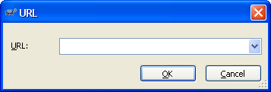

Enter the URL of the repository you are interested in viewing, and click OK. You will then get a window that allows you to view and navigate the repository that looks like this:

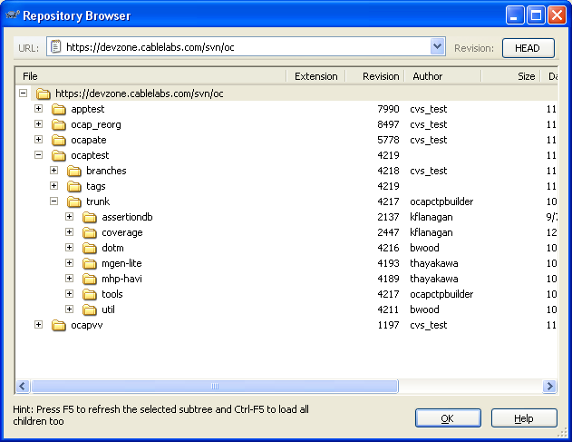

Files within the repository can be opened with their native applications, or one of your choice.

- Checking Out
To check code out with TortoiseSVN, right-click to get the context-sensitive menu, and select “SVN Checkout…”. This will give you a pop-up window that allows you to specify the repository to check out from, the local folder to place it in, and other options such as which revision to check out.

- Check For Modifications
This menu option is the analog to running “svn status” on the command line. Click the “Check Repository” button on the pop-up to see if there are changes in the repository that are not in your local copy.

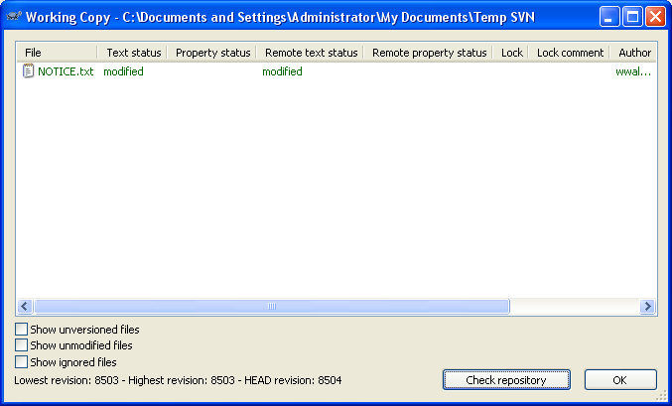

- Resolving Conflicts and Checking In
Once you have edited a file and are ready to check it in, highlight it and right-click to get the context-sensitive menu. The options will have changed, and now provide you the ability to update or commit. Updating first is strongly recommended if you are working on shared files as this will let you know if the file is in conflict.

If edits are in the repository that are not in your local copy, and conflict with edits that are in your local copy, the files will be in conflict and generate the same files and conflict markers as in the command line. An example would be:

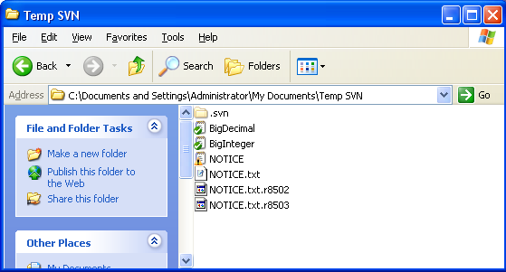

These files give you the information necessary to resolve the conflict by making appropriate changes to the file. A menu option is also available to “Edit Conflicts”, which pops up a 3-paned window that shows the edits in the repository, your local edits, and an attempt at merging.

Once the changes are made to resolve the conflict, select “Resolved” from the menu and the files will be cleaned up, leaving only the original. It can now be checked in.’

- Finding Differences Between Revisions
To examine differences between different revisions of a file, highlight the file in your current working copy, right-click, and select TortoiseSVN->Show Log. This will display a list of revisions of that file. For example:

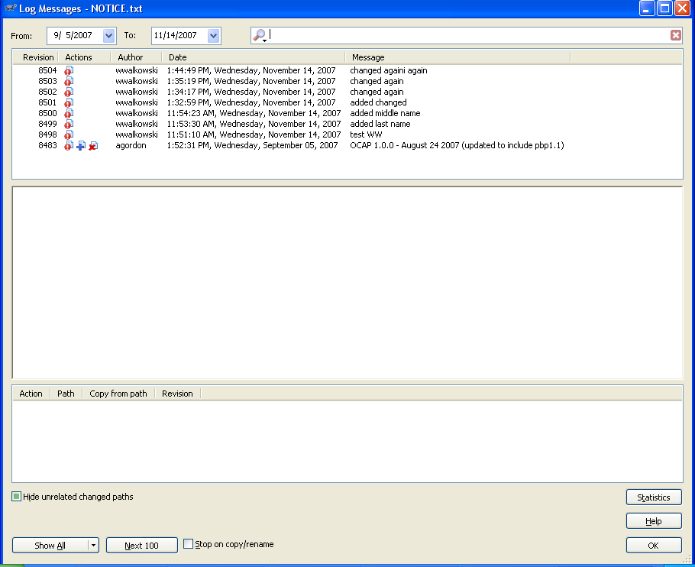

To diff two revisions, select one, hold down Ctrl, select another, right click on one of them, and select “Compare Revisions”. This will diff the files, bringing up a window with the 2 copies shown side by side, color coded to show what they are.

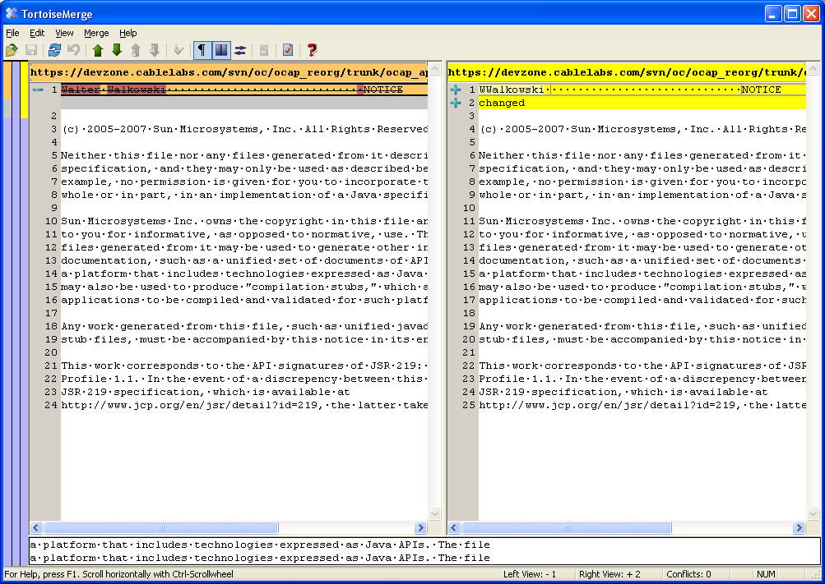

By right-clicking and selecting “Blame Revisions”, it will show the date and time stamp, the author and the changes, with the files shown side by side and color coded.

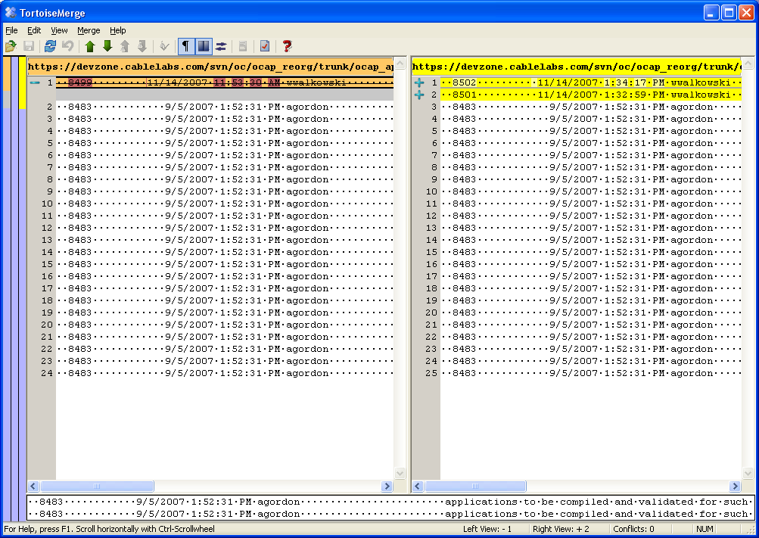

Subclipse Plug-In for Eclipse
Subclipse is a plug-in that allows Subversion use within Eclipse. The primary site for Subclipse is http://subclipse.tigris.org/ and installation and use instructions can be found at an IBM website located at http://www-128.ibm.com/developerworks/java/library/j-subversion/index.html.

If you are using the IBM site for installation instructions, note that the Subclipse URL you should use when installing within Eclipse is actually
http://subclipse.tigris.org/update_1.2.x , and not
http://subclipse.tigris.org/update_1.0.x as stated in the article.

Status Codes For “svn update” Command
These codes are listed here as a quick refererence. For more details see the explanation of “svn update” in the Subversion manual ( http://svnbook.red-bean.com/ ).
A Added
D Deleted
U Updated
C Conflicted
G Merged

Status Codes For “svn status” Command
These codes are listed here as a quick refererence. For more details see the explanation of “svn status” in the Subversion manual ( http://svnbook.red-bean.com/ ).

The codes most commonly seen are:
'A' Item is scheduled for Addition.
'D' Item is scheduled for Deletion.
'M' Item has been modified.
'?' Item is not under version control.
'*' A newer revision of the item exists on the server.

The first column indicates that an item was added, deleted, or otherwise changed.
' ' No modifications.
'A' Item is scheduled for Addition.
'D' Item is scheduled for Deletion.
'M' Item has been modified.
'R' Item has been replaced in your working copy. This means the file was scheduled for deletion, and then a new file with the same name was scheduled for addition in its place.
'C' The contents (as opposed to the properties) of the item conflict with updates received from the repository.
'X' Item is present because of an externals definition.
'I' Item is being ignored (e.g. with the svn:ignore property).
'?' Item is not under version control.
'!' Item is missing (e.g. you moved or deleted it without using svn). This also indicates that a directory is incomplete (a checkout or update was interrupted).
'~' Item is versioned as one kind of object (file, directory, link), but has been replaced by different kind of object.

The second column tells the status of a file's or directory's properties.
' ' No modifications.
'M' Properties for this item have been modified.
'C' Properties for this item are in conflict with property updates received from the repository.

The third column is populated only if the working copy directory is locked.
' ' Item is not locked.
'L' Item is locked.

The fourth column is populated only if the item is scheduled for addition-with-history.
' ' No history scheduled with commit.
'+' History scheduled with commit.

The sixth column is populated with lock information.
' ' When --show-updates is used, the file is not locked. If --show-updates is not used, this merely means that the file is not locked in this working copy.
K File is locked in this working copy.
O File is locked either by another user or in another working copy. This only appears when --show-updates is used.
T File was locked in this working copy, but the lock has been “stolen” and is invalid. The file is currently locked in the repository. This only appears when --show-updates is used.
B File was locked in this working copy, but the lock has been “broken” and is invalid. The file is no longer locked This only appears when --show-updates is used.

The out-of-date information appears in the seventh column (only if you pass the --show-updates option).
' ' The item in your working copy is up-to-date.
'*' A newer revision of the item exists on the server.

Subversion Command Cheat Sheet
The following tables are provided as reference and are copied from the Subversion manual.

They list all the commands in Subversion, with a brief description of each, a note on whether they access the repository, with each command being a hyperlink to the section of the manual that provides more detailed information about the command.

svn Subcommands

Command Alternate Description Repository

Name Access
svn add |  | Add files, directories, or symbolic links
svn blame | praise, annotate, ann | Show author and revision information in-line for the specified files or URLs | Yes
svn cat |  | Output the contents of the specified files or URLs | Yes
svn checkout | co | Check out a working copy from a repository | Yes
svn cleanup |  | Recursively clean up the working copy.
svn commit | ci | Send changes from your working copy to the repository. | Yes
svn copy | cp | Copy a file or directory in a working copy or in the repository. | If source or destination is in the repository
svn delete | del, remove, rm | Delete an item from a working copy or the repository. | Only if operating on URLs
svn diff | di | Display the differences between two paths. | For obtaining previous versions
svn export |  | Export a clean directory tree | If exporting from a URL
svn help | ?, h
svn import |  | Commit an unversioned file or tree into the repository | Yes
svn info |  | Display information about a local or remote item. | If operating on a URL
svn list | ls | List directory entries in the repository. | Yes
svn lock |  | Lock working copy paths or URLs in the repository, so that no other user can commit changes to them. | Yes
svn log |  | Display commit log messages. | Yes
svn merge |  | Apply the differences between two sources to a working copy path. | Only if working with URLs
svn mkdir |  | Create a new directory under version control. | Only if operating on a URL
svn move | mv, rename, ren | Move a file or directory. | Only if operating on a URL
svn propdel | pdel, pd | Remove a property from an item. | Only if operating on a URL
svn propedit | pedit, pe | Edit the property of one or more items under version control. | Only if operating on a URL
svn propget | pget, pg | Print the value of a property. | Only if operating on a URL
svn proplist | plist, pl | List all properties | Only if operating on a URL
svn propset | pset, ps | Set PROPNAME to PROPVAL on files, directories, or revisions | Only if operating on a URL
svn resolved |  | Remove “conflicted” state on working copy files or directories
svn revert |  | Undo all local edits
svn status | stat, st | Print the status of working copy files and directories | Only if using --show-updates
svn switch | sw | Update working copy to a different URL | Yes
svn unlock |  | Unlock working copy paths or URLs | Yes
svn update | up | Update your working copy | Yes

svnadmin

Command Description
svnadmin create | Create a new, empty repository
svnadmin deltify | Deltify changed paths in a revision range
svnadmin dump | Deltify changed paths in a revision range
svnadmin help
svnadmin hotcopy | Make a hot copy of a repository
svnadmin list-dblogs | Ask Berkeley DB which log files exist for a given Subversion repository (applies only to repositories using the bdb backend).
svnadmin list-unused-dblogs | Ask Berkeley DB which log files can be safely deleted (applies only to repositories using the bdb backend).
svnadmin load | Read a “dumpfile”-formatted stream from stdin
svnadmin lslocks | Print descriptions of all locks
svnadmin lstxns | Print the names of all uncommitted transactions
svnadmin recover | Bring a repository database back into a consistent state (applies only to repositories using the bdb backend). In addition, if repos/conf/passwd does not exist, it will create a default password file
svnadmin rmlocks | Unconditionally remove one or more locks from a repository
svnadmin rmtxns | Delete transactions from a repository
svnadmin setlog | Set the log-message on a revision
svnadmin verify | Verify the data stored in the repository

svnlook

Command Description
svnlook author | Print the author
svnlook cat | Print the contents of a file.
svnlook changed | Print the paths that were changed.
svnlook date | Print the datestamp.
svnlook diff | Print differences of changed files and properties.
svnlook dirs-changed | Print the directories that were themselves changed.
svnlook help
svnlook history | Print information about the history of a path in the repository (or the root directory if no path is supplied).
svnlook info | Print the author, datestamp, log message size, and log message
svnlook lock | If a lock exists on a path in the repository, describe it.
svnlook log | Print the log message.
svnlook propget | Print the raw value of a property on a path in the repository.
svnlook proplist | Print the names and values of versioned file and directory properties.
svnlook tree | Print the tree.
svnlook uuid | Print the repository's UUID.
svnlook youngest | Print the youngest revision number.

Properties

Command Description
Subversion properties | Subversion allows users to invent arbitrarily-named versioned properties on files and directories, as well as unversioned properties on revisions. The only restriction is on properties whose names begin with svn: (those are reserved for Subversion's own use). While these properties may be set by users to control Subversion's behavior, users may not invent new svn: properties.
Versioned Properties
Unversioned Properties

Repository Hooks

Command Description
start-commit | The start-commit hook is run before the commit transaction is even created. It is typically used to decide if the user has commit privileges at all.
pre-commit | The pre-commit hook is run just before a commit transaction is promoted to a new revision. Typically, this hook is used to protect against commits that are disallowed due to content or location (for example, your site might require that all commits to a certain branch include a ticket number from the bug tracker, or that the incoming log message is non-empty).
post-commit | The post-commit hook is run after the transaction is committed, and a new revision created. Most people use this hook to send out descriptive emails about the commit or to notify some other tool (such as an issue tracker) that a commit has happened. Some configurations also use this hook to trigger backup processes.
pre-revprop-change | The pre-revprop-change hook is run immediately prior to the modification of a revision property when performed outside the scope of a normal commit. Unlike the other hooks, the default state of this one is to deny the proposed action. The hook must actually exist and return a zero exit value before a revision property modification can happen.
post-revprop-change | The post-revprop-change hook is run immediately after to the modification of a revision property when performed outside the scope of a normal commit. As can be derived from the description of its counterpart, the pre-revprop-change hook, this hook will not run at all unless the pre-revprop-change hook is implemented. It is typically used to send email notification of the property change.
pre-lock | The pre-lock hook runs whenever someone attempts to lock a path. It can be used to prevent locks altogether, or to create a more complex policy specifying exactly which users are allowed to lock particular paths. If the hook notices a pre-existing lock, then it can also decide whether a user is allowed to “steal” the existing lock.
post-lock | The post-lock hook runs after one or more paths has been locked. It is typically used to send email notification of the lock event.
pre-unlock | The pre-unlock hook runs whenever someone attempts to remove a lock on a file. It can be used to create policies that specify which users are allowed to unlock particular paths. It's particularly important for determining policies about lock breakage. If user A locks a file, is user B allowed to break the lock? What if the lock is more than a week old? These sorts of things can be decided and enforced by the hook.
post-unlock | The post-unlock hook runs after one or more paths has been unlocked. It is typically used to send email notification of the unlock event.

TortoiseSVN Lessons Learned

- Editing the config file to set EOL to Line Feed
(As of Feburary 8, 2008, implementing this section is required when working in the “ocaptest” repository. If you work outside of “ocaptest”, you may follow this if you want your files to have Unix style line feeds.)

The config file needs to be edited to specify which file types should have Unix style line endings. Otherwise, files can be checked into Subversion with Windows-style line endings and cause problems.

To edit the config file, right-click on the desktop, and from the menu select TortoiseSVN->Settings. You will see a window like this:
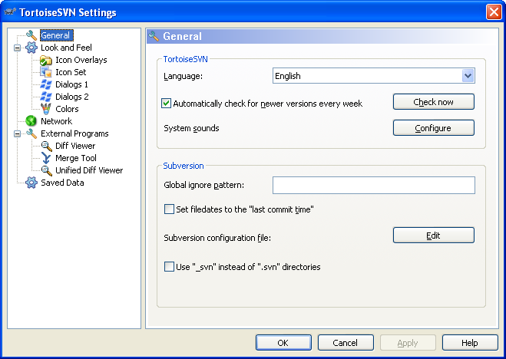

Click on Edit, and it will bring up a Notepad window with the config file in it.

Scroll down to the bottom, and uncomment the line “enable-auto-props = yes”. This turns on the auto-props that you are about to set. IMPORTANT: Ensure that there are NO leading spaces in any lines you add or edit. This will cause an error the next time you run TortioseSVN.

In the section following that, “[auto-props]”, uncomment (or add) the lines to set the “eol-style” to “LF” for at least the following file types:
*.txt = svn:eol-style=LF
*.java = svn:eol-style= LF
*.m = svn:eol-style= LF
*.xml = svn:eol-style= LF

You can copy & paste the above into your config file.

An example config file is shown below:
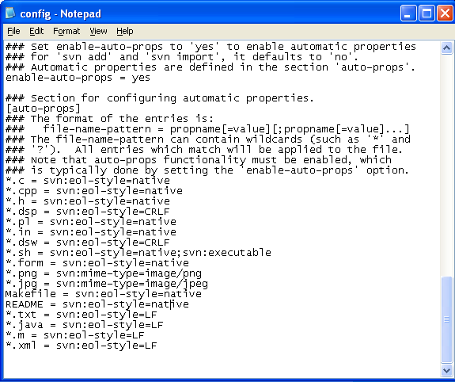

Again, ensure that there are NO leading spaces in any lines you add or edit.

These file types are project dependent, and therefore may be different across different projects/managers. If more file types are needed, add them the same way.

- Checking out ocaptest
Some people have problems checking out ocaptest/trunk. Some do not. Those who do, have problems in the “mhp-havi” directory.

To increase your chances of success, set Icon Overlays to “shell” in TortoiseSVN. This prevents a TortoiseSVN related process called TSVNCache from crawling your hard drive when you are checking out ocaptest/trunk. (TSVNCache checks if files have changed on your hard drive in order to put the little status icons on the files when you view them.) Although it is Tortoise related, it still causes problems with the check out.

To set Icon Overlays to “shell”, right-click on the desktop, select
TortoiseSVN->Settings, and select “Icon Overlays” in the menu on the left.

You will get a screen like this:
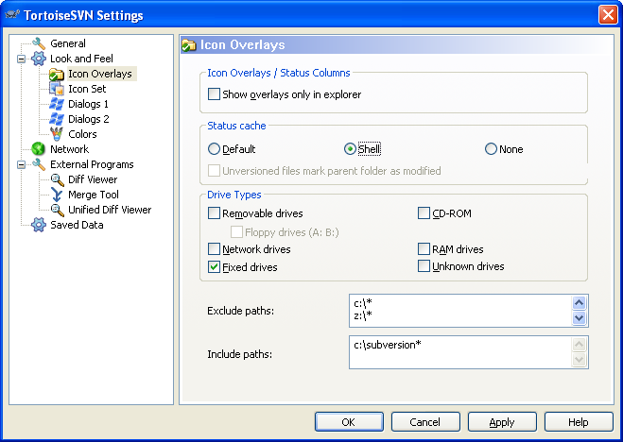

Once set to “shell”, click OK.

The other result of setting the Icon Overlays to shell is that the Icon Overlays are not recursive. That is, if a file changed within a folder, the folder’s status will not change. This means you have to navigate to inside a folder to see if anything changed, and cannot tell just by looking at the folder. This can be reset to “Default” when the check out of ocaptest/trunk is complete to give recursive Icon Overlays.

If your checkout of ocaptest/trunk fails mid-way in the “mhp-havi” directory, navigate to the folder where you checked out ocaptest/trunk, and do an SVN Update command. This will check out the remaining files and you will be able to view and use all of them.

- Exclude paths, include paths
A process called TSVNCache constantly checks if files have changed on your hard drive in order to put the little status icons on the files when you view them. Since it constantly checks all your hard drives, it may degrade the overall performance of your PC, even if you are not doing anything with TortoiseSVN.

To prevent the TSVNCache process from crawling your entire PC, you can tell it what paths to ignore and what paths to crawl. This will prevent it from degrading the performance of the your machine.

To use this feature, go to the screen described in step 2 above, and set “Exclude paths” to all your hard drives, and set “Include paths” to only the folder into which you check out your code from Subversion. (It is recommended that you have one high-level folder for checking out from Subversion. This folder should never be deleted or renamed, whereas folders below it can come and go as you need them.) Follow the syntax in the screenshot above, and include all hard drives that are on your PC. Networked hard drives are excluded by default.

